**5.h9LARGEST NUMBER IN AN ARRAY**

**EXP NO: 10**

**AIM:** To find the largest number from an array using 8085 processor.

**ALGORITHM:**

1. Load the address of the first element of the array in HL pair.
2. Move the count to B register.
3. Increment the pointer.
4. Get the first data in A register.
5. Decrement the count.
6. Increment the pointer.
7. Compare the content of memory addressed by HL pair with that of A register.
8. If carry=0, go to step 10 or if carry=1 go to step 9
9. Move the content of memory addressed by HL to A register.
10. Decrement the count.

**PROGRAM:**

LXI H,2050

MOV C,M

DCR C

INX H

MOV A,M

LOOP1: INX H

CMP M

JNC LOOP

MOV A,M

LOOP: DCR C

JNZ LOOP1

STA 2058

HLT

**OUTPUT:**

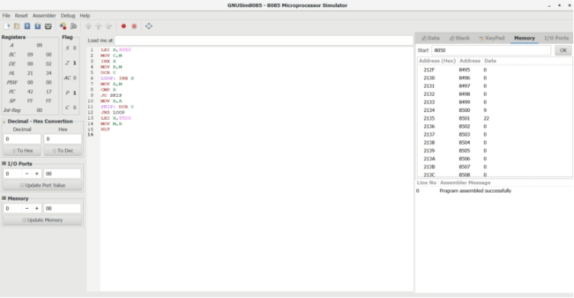

**RESULT:** Thus the program was executed successfully using 8086 processor simulator.